HCI Design Brief

Project: *VR Space Science Module*

*Queensland Schools of Distance Education*

Author:

S Number:

*Workshop:*

Table of Contents

1 Introduction 1

1.1 Purpose of this document 1

1.2 Scope of this document 1

1.3 Background 1

1.4 Problem statement 1

1.5 Proposed solution 1

2 Audience 2

2.1 User Research - Desired 2

2.2 User Research – Actual 2

2.3 Human Factors 3

3 Usability 4

3.1 Usability Tools 4

3.2 Usability Findings 4

3.3 Usability Objectives 6

4 Design 7

5 Prototype 8

5.1 Stage One – Low-Fidelity Prototype 8

6 Discussion – User Involvement 9

7 Testing 9

7.1 Test Plan 9

7.1.1 Testing Purpose and Goals………………………………………...9

7.1.2 Participant Characteristics………………………………………...10

7.1.3 Method………………………………………………………………10

7.1.4 Task List…………………………………………………………….11

7.1.5 Data………………………………………………………………….12

7.2 Test Results and Analysis 13

7.3 Findings and Recommendations 13

8 Discussion – Accessibility 14

9 Prototype 14

9.1 Stage Two – High-Fidelity Prototype 14

10 Discussion – Domains 14

11 Discussion – Emerging Technology 15

# Introduction

## Purpose of this document

This project document has been prepared for Queensland Schools of Distance Education to enhance the imagination and the motivation of the school students towards the Space Science. The purpose of this document is to detail the work and findings of the design process when developing a new product for the client, and eventually provide a solution that client is looking for. This document includes the development of a digital module to enhance the enthusiasm of the students from gathering information and proceeding it to the level of making the prototype of the proposed module.

## Scope of this document

This design document will cover the background of the project, what the problem is addressing and the value it will provide. It will also discuss the target audience, usability objectives, the design requirement as well as including a low fidelity prototype of the product. It will not include a discussion of implementation of the product, or the broader training program that will use this product.

## Background

Space Science is one of the amazing Science areas and it can make people think beyond their comfort zone regarding the world that we live on.

Generally, most of the students don’t want to choose the path of being a Scientist when they realised the hard work and the researches that they have seen. Therefore, the imagination skills are very low as well as they are not motivated much. This can be changed if people are having the basic knowledge and the taste of what Space Science really is.

## Problem statement

Queensland Schools of Distance Education have contacted us through a need to improve the imaginations of their students and motivate students’ interest in the Space Sciences.

The benefits are great for both the client and the students. The client can develop a new effective way of providing the enthusiasm to get their students motivated into the Space Sciences and use the students’ imagination skills to think differently.

## Proposed solution

In order to solve the Scientific imagination and the motivation improvement problem, we propose an interactive Virtual Reality Space module simulator that allows the student to roam around in a Virtual Space reality and walk through different space components and create or change the virtual module as the student preferences. Virtual Reality environment is being designed by the Unity Development Platform and there will be different space environment selections as well as the custom template to create student’s own imagined space environment.

# Audience

## User Research - Desired

It would be a great opportunity to collect all the necessary information and start the research by visiting them face to face and making interviews, discussion groups and provide some questionnaires to all the primary students and get their feedback on it. It would be the best way to identify their behavioural aspects as well as their critical thinking regarding to this topic and how their imagination works.

Conducting contextual interviews and the discussions with the students could ask for their opinions directly such as if they would be interested in a Virtual reality Space simulated model to improve and maximize their imagination skills and their interest in the Space science field.

You could even do a full ethnographic study but that and the contextual interviews would require a long time to receive the important information required.

This is where using focus groups would be the most useful to receive the information about the audience, even sending out surveys and questionnaires beforehand to receive a large amount of basic information about the different demographics to use as discussion topics for the focus groups.

But the most important part is to analyse the information receive and see what audience exactly the product appals to and who will be using it.

## User Research – Actual

I was not able to participate in a real primary school class and attain the necessary information, but conducted a general research instead. According to the Chief Scientist Office of Australian Government, the summary information which I was able to attained from the article “Science and Maths in Australia Secondary Schools” is;

1. Australia’s international PISA ranking has declined in science from 4th to 8th scoring 527 in 2006 to 521 in 2012.
2. Participation for science subjects is declining and it is lowest in 20 years among maths and science.
3. Fewer Australian students performed at TIMSS advance levels of science which is 11% compared with the top five countries which is 23%.
4. Older students tend to lose interest in science.
5. Students in metropolitan areas significantly outperformed compared to remote area.

|  |  |  |  |  |
| --- | --- | --- | --- | --- |
| **Characteristic** | **Group 1** | | **Group 2** | |
| Age | 5-9 years | | 9-13 years | |
| Gender | Male | Female | Male | Female |
| Knowledge of VR technology | Moderate | Weak | Very Strong | Strong |
| Science Scores | 49.77% | 50.23% | 50% | 50% |
| Interest in Science | Lose Interest Over the time | | | |
| Performance | Girls perform greater than boys | | | |
| Socio-economic status | High socio-economic status background students have outperformed than low SES backgrounds | | | |
| Living Area | Students in metropolitan areas have outperformed compared to Remote area students | | | |

## Human Factors

There are few human factors to consider when designing this product and how it will affect each student’s experience. Taking this into consideration I will try to accommodate for as many demographics and disabilities as possible. In this situation there are few of the main Dirty Dozen Human Factors we need to consider as well.

Knowledge and the Awareness are slightly required in using this product otherwise it would be in a minor way because here we are using a VR technology as our product. According to our survey almost all the male students are aware of this VR technology rather the female students that we surveyed.

Feeling the virtual environment is a very important part of VR simulations it is because the student has to think he is living in the virtual reality and work according to the Virtual reality by expressing his/her emotions and imaginations to build up a custom space environment.

This VR simulation module would be easy to use by those who are not much aware of the VR technology and it will give a small tutorial to each and every student before using it. This would also give the Student to choose different space environments such as The Earth, moon, sun system, galaxies and even it could choose to explore and learn the history and present of each and every selected component. Later on, it will change it to a virtual window where the student can make their own path to the Space and select what he/she wants to learn and explore and what else would help them to achieve their virtually created scenario.

# Usability

## Usability Tools

A survey tool was use to generate broad feedback to learn about the learning patterns and the awareness of the Space Science that students have in different age levels. I had created a Survey (figure 3.1) to send to 150 students who were currently being studying at one of my colleague’s sister’s school (30 students per year and altogether there were 5 different years). As well as I had planned to get some feedback from the teachers who do sciences in these students’ classes, but I was unable to get the total number of feedbacks as planned.

The survey had questions that were able to determine their demographic such as age, gender, living area, socio-economic status and their interest in the school activities related to the field of science. It was also able to determine which audience group the surveyed person belonged to, as well as what they believed their performance as well as the level of imagination skills and the level of how they are motivated on Space Sciences was.

## Usability Findings

I was able to classify my findings into three groups and underneath there are combinations of few personas from each group to have a basic idea about each category group. It covers the major potion from the target audience as well.

|  |  |  |  |
| --- | --- | --- | --- |
| **Attribute** | **Findings** | | |
| **Class 1** | **Class 2** | **Class 3** |
| Age | 5-8 | 8-11 | 11-13 |
| Gender | Male/Female | Male/Female | Male/Female |
| Living Area | Metropolitan | Metropolitan | Metropolitan |
| SES | High | Moderate | Moderate |
| Science Results | ~ 90% | ~ 72% | ~ 65% |
| Interest in Science | High | Moderate | Moderate |
| Imagination Skills | High | Moderate | Poor |
| Motivation provided by the school | High | Poor | Poor |
| Technology competence | High | High | High |
| Requested features | Space related VR games | - | Walk through demonstrations using VR |

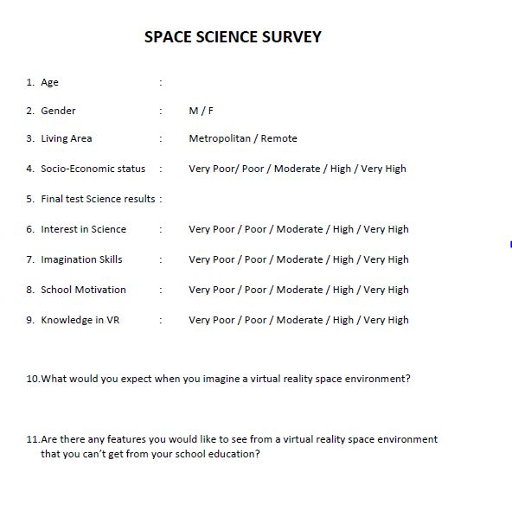

figure 3.1

## Usability Objectives

I wish to achieve at least 80% - 90% success usability rate from each of the aspects. Therefore, testers from different age levels and both male and female students were chosen. It really helped to get the most accurate data feedback regarding the usability.

The usability objectives for the VR Space simulation module are:

|  |  |  |  |
| --- | --- | --- | --- |
| **Aspect of solution** | **Usability goal** | **How is this measured?** | **Success criteria** |
| Opening the app | Users can open the application with little to no difficulty | Time taken to successfully open the app on a test phone | 90% of testers can open the app within 10 seconds of identifying the appropriate icon. |
| Mounting the VR | Users can mount the VR with little to no difficulty | Time taken to successfully mount the VR and adjust it | 95% Male testers and 80% females are able to do within 10seconds |
| Identifying Interface modules | Users can identify the each and every function mentioned in the interface | Time taken to move to the start function from the start | 75% testers are able to identify the path within 20 seconds. |
| Adapting to VR interface | Users should have no any difficulty using the App through the VR | Who have stayed more time from the start | 60% testers can success |
| Ability to walk through and navigate in the VR | Users should be entertained and motivated with high interest | Who have stayed more time after the tutorial | 90% of testers are able to stay more additional time |

# Design

The Visual design is much colourful and tricky because the target audience is mostly the primary school students therefore it would help to get their attraction towards this module even before they start to observe it. Simple menus will be used with few options for tutorial demonstration, selecting the space objects, learn more as well as for creating an own custom space environment. The settings and close buttons (figure 4.1) will be in an easy reach which on the two of the top corners only displaying the icons rather than the words. There won’t be any other game play functions that have to do by hands because this is a VR simulation. Choosing and going forward can be done by head tilting (figure 4.2)

The products navigation is consistent: easy reach for the settings and closing the app and all the other gameplay features done by the head tilting using the VR box.

All text used within the simulator will be bold and italic and have average size letters that giving the more space for the Space environment.

The colour palette will mainly be black to white (figure 4.3) because it contrasts and highlights the uniqueness of the simulator.

Different type of videos and images are used to make the interaction between the VR and the Space environment as well as the user is able to make the changes on those different interfaces as he/she feels and work according to the imagination that person has on mind.

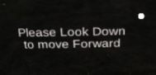

Close Settings

figure 4.1 figure 4.2



figure 4.3

# Prototype

## Stage One – Low-Fidelity Prototype

Below are the figures 5.1 to 5.3 which make up a low fidelity prototype in the form of a storyboard, demonstrating a few of the functionalities of the product. Figure 5.1 is the start of the product and how the user sees when he mounts the VR box. This is presented every time the player starts the program. User can go on to selection panel, settings or even close the product at this stage.

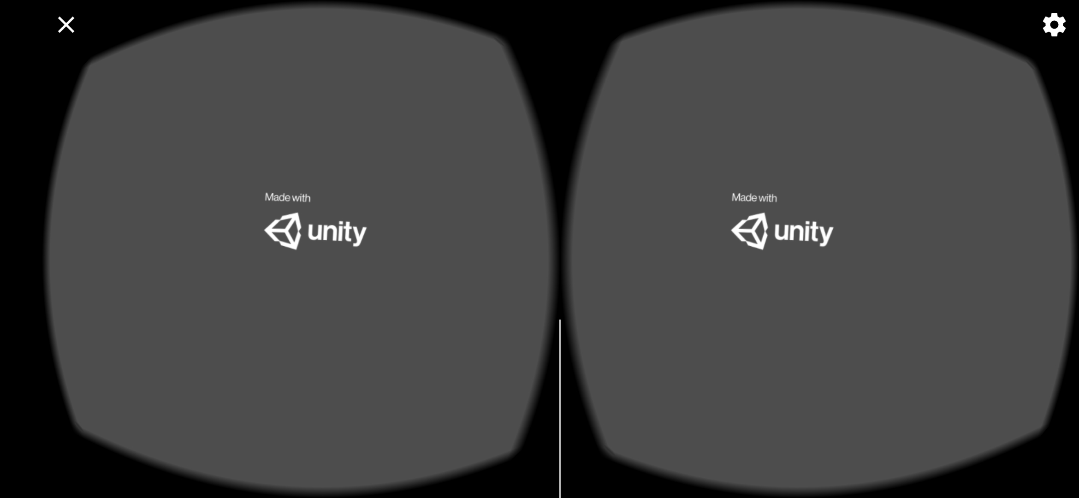Figure 5.2 shows the home page of this product and the user can roam around freely before he enters into the space environment. He has to go through the door appearing in the figure 5.2 to get on to the Space environment. When the user enters that person is given a selection panel.

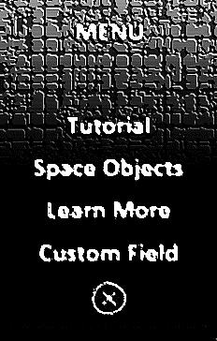

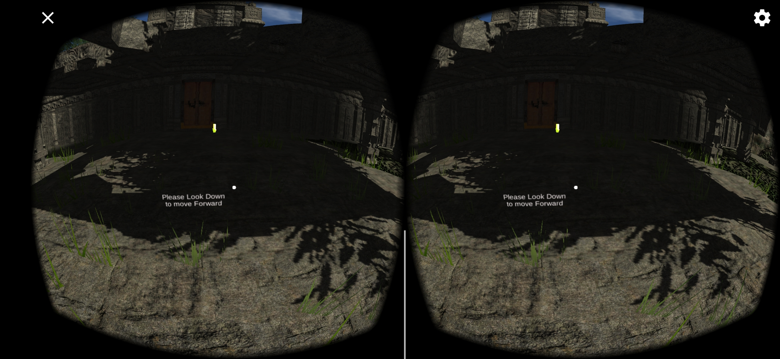 Figure 5.1

Figure 5.3

Figure 5.2

Figure 5.3 shows the selection panel when the user walks through the door. Then the user can choose one option from the tutorial, select space objects, learn more, custom space environment. Once the player has chosen the option they wish to practise on, they can tilt them to start the simulation. The person will be placed in a space environment like that person is floating in the space.

# Discussion – User Involvement

My use of student involvement for the project has been at an average level because of my colleague’s sister is a primary school student and the access to students is pretty much high. I have been able to survey around 150 students and access few students for usability testing.

Students were more excited to try on the VR box rather than getting much knowledge into the Space Science simulator but that helped a lot to get feedback out of many students because they were tend to make comments because of the tech equipment. Most of the students don’t get much motivation from their school when they pass on to the higher classes. Students do have different type of imagination skills as what they have told but that rapidly decreases because more they get older, more they stay away from trying out new things and make something of their own because of the competition they have to pass the exams in good grades and get into a good high school.

This survey is only for the students and I think that is major issue it is because from the information that I have collected most of the students blame the school for not motivating them in to different amazing areas. It would have been a much more efficient if there was another survey for school teachers as well as for some of their parents to get the exact information about what are the major issues for this drawback.

Having a pre session on importance of sciences and the future of the space sciences would have been one of the best way to drag a lot of students as well as other related parties for this survey and get feedbacks according to our requirements that we need to make up a product.

# Testing

## Test Plan

### Testing Purpose and Goals

During this iteration of tests, I have set out to achieve the goal of clarifying the project design. The purpose of the test is to find difficulties and problems navigating through the selection panel and to answer the questions:

* What are the obstacles that the user comes across when they try to reach their desired objective through the selection panel?
* How efficient the user interacts with selection panel and the space environment mode?
* Are the users able to identify the patterns and walk alone the environment and have an entertaining and enthusiastic session throughout the product.
* Are the users have evolved their imagination skills and used it as a weapon to make custom space environments?

### Participant Characteristics

The Characteristics of the participants in the testing is broken down into the main target audiences for the product. It would also be good to test with some students who didn’t participate for the survey to find out what would be the initial thought and feedback regarding the product and how others will think about the concept of motivating and improvising the imagination skills of the user.

Ideally having 10 students from each target audience would yield the most accurate results as well as it would be much more possible to way as well.

|  |  |
| --- | --- |
| **Characteristic** | **Desired number**  **Of participants** |
| Students who were in the survey  Random Primary School Students | 10  10 |
| **Total number of participants** | 20 |
| Interest in Space Science  Not interested in Space Science | 9  11 |
| Age  5-8  8-11  11-13 | 10  6  4 |
| Gender  Female  Male | 12  8 |

### Method

The approach used in this stage of testing is System Testing because it is the most suitable option to use among students rather than the Unit testing. Unit testing would take much time and having different feedbacks would be a trouble from primary students because they are not much capable of interpreting exactly how they feel on certain points. Therefore, getting an overall testing over the system would be the best solution and it would help to understand the reliability of the product.

The test sessions will be only 35 minutes long per each group. I will use 10 minutes of each session for pre-introduction and post-test debriefing interviews. The sessions will take place at the Science Laboratory of the Primary-School.

**Pre-test arrangements**

* Gather a single test group to the location
* Hand over a questionnaire to participants

**Introduction to the session (4 minutes)**

Discuss:

* Participants’ experience with this kind of process
* Importance of their involvement in this study
* Moderator’s role
* Room configuration, recording systems, observers, etc.
* The protocol for the rest of the session
* Reasons for wanting to improve the imagination skills and the usefulness of the Space Sciences

**Tasks (25 minutes)**

Participants will work through the space environment interaction with the prototype VR simulation. Full details are provided in section 7.1.4.

**Post-test debriefing (6 minutes)**

* Ask broad questions to collect preference and other qualitative data
* Follow up on any particular problems that came up for the participant

### Task List

**Task 1** Interact with the user interface to navigate through the selection panel

**State** Unity platform VR prototype of the user interface of the Space Environment simulator

**Successful completion** Participant selects correct path

**Benchmark** Participant selects the path by tilting their heads after the welcome screen

**Task 2** Start the Elements in Space Tutorial

**State** Unity platform VR prototype of the user interface of the Space Environment simulator

**Successful completion** Participant completes the tutorial

**Benchmark** Participant walks through the space environment for 6-7minutes till it reach the finishing door of the interface.

**Task 3** Close the current window by walking through the door and come back to the Main menu

**State** Unity platform VR prototype of the user interface of the Space Environment simulator

**Successful completion** Participant comes to menu

**Benchmark** Participant walks through the door

**Task 4** Walk through different space objects

**State** Unity platform VR prototype of the user interface of the Space Environment simulator

**Successful completion** Get a basic knowledge to fill the blanks in the questionnaire

**Benchmark** Participant completes all the objects in 6-7minutes

**Task 5** Make their own space elements throughout the custom space environment

**State** Unity platform VR prototype of the user interface of the Space Environment simulator

**Successful completion** improved imagination skilled designs

**Benchmark** Participant completes all the designs in 6-7minutes

### Data

To answer the question, “What obstacles do students encounter as they come across when they try to reach their desired objective through the simulator after completing their VR Space elements simulation?” I will collect data for:

* Time It takes the user to reach the final custom element building environment
* Number of replays and no improvement on the custom section
* The appropriateness of options with the menus
* Usefulness of terms and labels
* Number of drawbacks happened due to user errors

## Test Results and Analysis

The testing was conducted on the 5th of August with a total 20 participants. This was exactly the ideal number of participants I needed for the test session. Ten of the participants are well known about the survey that we did from the beginning and the rest of ten participants are newly taken only for the testing phase. Therefore, those participants were broken down into two groups and made the test session separately.

The users were presented with a questionnaire which they needed to fill at end of the testing session before they leave the room as well as each of them were given separate VR boxes with the pre-installed Unity simulation app.

The test results show that the users are able to complete all the tasks to a successful standard under the time limit and with minimal mistakes. The results were very consistent between all the participants.

The Users were all able to identify and explain the different user interface modules within the VR Space environment simulator within the time limit.

## Findings and Recommendations

The results from these tests show that generally the design of the selection panel is simple and easy to use because there are only tilting gestures done by the head, as users are able to navigate to their desired section with ease. As well as throughout the test results the significant point that I was able to collect is that there should be different type of levels in the simulator. Therefore, the user can select each different level when they desire to walk around and it will surely improve the imagination skills than the basic product concept of mine.

One of the issues I identified on the space environment is there are no any extent where the user can go. The problem that arises from that issue is when the user designs his/her own space element environment sometimes that user couldn’t find what he/she has created previously.

The last issue that was discovered was that users could not identify some data due to the black to white colour palette I used. According to feedbacks changing it to a more colourful palette will change aspect of it.

As for a major recommendation what I got was to build a gameplay in my product. It is because most of the users are primary school students therefore, they are more likely to be around games and fun activities so building up a small puzzle game or a naming game in different elements of the space environment would be much more accurate according to their feedbacks.

The last recommendation was to make few voice notes on different imaginary space elements and let the student design it in his virtual reality. According to the feedbacks that is one of the major ways to improve and motivate the imagination skills and well as make students fonder over the space sciences.

# Discussion – Accessibility

This Elements in Space Environment VR simulator is mainly focused and accessible by the Primary School students to improve their imagination skills and motivate their interest on space sciences by providing tours over our solar system and other galaxies as well as the key information such as space elements, including planets, moons, asteroids and stars.

Anyone without basic knowledge regarding space sciences could use this product to evolve their knowledge of the space sciences because it provides information which are very much important to any human being. People who are with stress problems can access this product to calm down their mind by surfing around the space environment.

To use this product the user should have an Android operating system device with a VR box. Otherwise this product won’t be any useful to any user it is because this product works only with Android as well as having a VR box is a must.

# Prototype

## Stage Two – High-Fidelity Prototype

The user VR interface and the space environment starting module is pretty much same as the stage one prototype. Based on the results from the player testing there has been an overall approval of the design as well as success in terms of usability. One of the main issues identified was not being able to keep a margin of your walk through. In the revised prototype I had redesigned it to have a fixed parameter extent where the user could walk through in the space environment.

In the revised prototype I had newly assigned few levels to choose which level each user prefers to use as well as for mind relaxing space environment sessions included Alpha wave music clips.

According to some of the recommendations I received for the product I had included a puzzle game regarding the space elements where anybody can participate and achieve some points and keep a track on it to make it more useful to learn and be motivated.

In the revised prototype interface colours also had changed into a more colourful colour palette consisting of Blue and Red which gives a unique user interface and experience design.

# Discussion – Domains

The project so far has been purely designed for primary school students to improve their imagination skills over the elements of the space environment. As well as the designed unity platform application can be only used from a Android Operating System. But with this in mind it would not be hard to enable support for other operating systems like IOS, Samsung One UI, Windows Mobile etc. This could also can be used by other students apart from the primary school students therefore any students as well as any person who has an interest over the space element environment can use this product to gain knowledge and improve their imagination skills.

This product would also help in the physiological field because roaming around in the imaginary space environment take people so far away from their living mind set. Therefore, people who are dealing with anxiety and depression problems could use this product as their therapy equipment to relax their mind while having an Alpha wave mind relaxing music which also emphasis the Space environment far away from our living comfort zone, earth.

# Discussion – Emerging Technology

The use of AR and XR could change the complete usability of this product. With those technologies they can have a virtual and real combined interface experience and users can improve their skills more effectively rather using the typical VR module.

Apart from the AR and XR, the use of Holograms also can change the future of this product. Therefore, users don’t have to wear VR boxes to use this product, they can freely use it as a real time interface with 3D modeled objects among the user.

XR and Hologram would let the user to get the real feeling of the space environment and that is more entertaining. It would help so much to improve the skills and motivate students at their younger ages due to these mystical technologies’ children tend to seek more.